Stock Market Price Prediction

Using

Machine Learning

**DESIGN PROJECT – II REPORT**

***Submitted by***

**K TITUS YESUDAS - 19113162**

**SAI PRANEETH – 19113169**

**PADALA JOSEPH - 19113176**

**Under the guidance of**

**DR. ANTONIDOSS A**

**Associate Professor**

***in partial fulfillment for the award of the degree of***

**BACHELOR OF TECHNOLOGY**

**in**

**COMPUTER SCIENCE AND ENGINEERING**



**HINDUSTAN INSTITUTE OF TECHNOLOGY AND SCIENCE**

**CHENNAI - 603 103**

APRIL 2022



**BONAFIDE CERTIFICATE**

Certified that this project report **STOCK MARKET PRICE PREDICTION USING TIME SERIES ANALYSIS** the bonafide work of **Titus Yesudas(19113162), Sai Praneeth(19113169), Padala Joseph(19113176)** who carried out the project work under my supervision during the academic year 2**021-2022**.

Dr.ANTONIDOSS A,

**PROJECT CO-ORDINATOR**

Associate Professor

Department of CSE.

**INTERNAL EXAMINER EXTERNAL EXAMINER**

Name: Designation:

Name:

Designation:

Project Viva - voce conducted on

**Abstract**

Researchers have been studying different methods to effectively predict the stock market price. Useful prediction systems allow traders to get better insights about data such as: future trends. Also, investors have a major benefit since the analysis give future conditions of the market. One such method is to use machine learning algorithms for forecasting. This project’s objective is to improve the quality of output of stock market predicted by using stock value. A number of researchers have come up with various ways to solve this problem, mainly there are traditional methods so far, such as artificial neural network is a way to get hidden patterns and classify the data which is used in predicting stock market. This project proposes a different method for prognosing stock market prices. It does not fit the data to a speciﬁc model; rather we are identifying the latent dynamics existing in the data using machine learning architectures. In this work we use Machine learning architectures Long Short-Term Memory (LSTM), Convolutional Neural Network (CNN) and Hybrid approach of LSTM + CNN for the price forecasting of NSE listed companies and differentiating their performance. On a long term basis, sling window approach has been applied and the performance was assessed by using root mean square error.

**ACKNOWLEDGEMENT**

First and foremost, we would like to thank **ALMIGHTY** who has provided us the strength to do justice to our work and contribute our best to it.

We wish to express our deep sense of gratitude from the bottom of our heart to our guide **Dr.ANTONIDOSS A, Associate Professor** , **Computer Science and Engineering,** for her motivating discussions, overwhelming suggestions, ingenious encouragement, invaluable supervision, and exemplary guidance throughout this project work.

We would like to extend our heartfelt gratitude to **Dr. J.Thngakumar, Ph.D., Professor & Head, Department of Computer Science and Engineering** for her valuable suggestions and support in successfully completing the project.

We thank the management of **HINDUSTAN INSTITUTE OF TECHNOLOGY AND SCIENCE** for providing us the necessary facilities and support required for the successful completion of the project.

As a final word, we would like to thank each and every individual who have been a source of support and encouragement and helped us to achieve our goal and complete our project work successfully.

**TABLE OF CONTENTS**

|  |  |  |
| --- | --- | --- |
| **SR.**  **NO.** | **TOPIC** | **PAGE**  **NO.** |
|  | Abstract…………………………………………………………… | I |
| Acknowledgements……………………………………………….. | II |
| Table of Contents…………………………………………………. | III |
| List of Figures…………………………………………………….. | IV |
| List of Table………………………………………………………. | VI |
| **1.** | **Introduction………………………………………………………** | **1** |
|  | 1.1 Stock Price Prediction………………………………………… | 1 |
|  | 1.2 Application …………………………………………………… | 3 |
|  | 1.3 Objectives……………………………………………………... | 3 |
|  | 1.4 Motivation…………………………………………………...... | 3 |
|  | 1.5 Organization of Report…………………………….………….. | 3 |
| **2.** | **Literature Survey…………………………………………………** | **4** |
| **3.** | **Existing work…….…………………....…………………………..** | **10** |
|  | 3.1 Overview of Existing work….………………………………… | 10 |
|  | 3.2 Proposed work…………………………………………………. | 11 |
|  | 3.2 1 Working of LSTM model……………………………….…… | 12 |
|  | 3.2.2 Working of CNN model……..……………………….……… | 14 |
|  | 3.2.3 Working of Hybrid approach of LSTM+CNN model….…..... | 15 |
| **4.** | **Dataset, Implementation and Results…………………….……..** | **16** |
|  | 4.1 Dataset Details………………………………………………… | 16 |
|  | 4.2 Tools & Technology used…………………………………….. | 17 |
|  | 4.3 Implementation Results……………..……………………..….. | 20 |
| **5.** | **Conclusion and Future work.…………………..…..……………** | **30** |

Bibliography and References 31

APPENDIX A: ABBRAVIATION… 34

|  |  |  |
| --- | --- | --- |
|  | **LIST OF FIGURES** |  |
| **FIGURE NO** | **TITLE** | **PAGE NO** |
| 3.1 | Proposed Work Flow | 11 |
| 3.2 | LSTM Architecture | 12 |
| 3.3 | CNN Architecture | 14 |
| 4.1 | Stock Dataset Information | 20 |
| 4.2 | Read Dataset | 20 |
| 4.3 | Graph of Close Price history | 21 |
| 4.4 | Data Scaling | 21 |
| 4.5. | LSTM Summary | 22 |
| 4.6 | CNN Summary | 22 |
| 4.7 | Hybride Approach of LSTM + CNN Summary | 23 |
| 4.8 | Training Process | 23 |
| 4.9 | Predicted Close Price | 24 |
| 4.10 | Plot for Real vs Predicted value for ICICI Bank using LSTM | 25 |
| 4.11 | Plot for Real vs Predicted value for ICICI Bank using CNN | 25 |
| 4.12 | Plot for Real vs Predicted value for ICICI Bank using LSTM + CNN | 25 |
| 4.13 | Plot for Real vs Predicted value for SUN PHARMA using LSTM | 26 |
| 4.14 | Plot for Real vs Predicted value for SUN PHARMA using CNN | 26 |
| 4.15 | Plot for Real vs Predicted value for SUN PHARMA using LSTM + CNN | 26 |
| 4.16 | Plot for Real vs Predicted value for GSFC using LSTM | 27 |
| 4.17 | Plot for Real vs Predicted value for GSFC using CNN | 27 |
| 4.18 | Plot for Real vs Predicted value for GSFC using LSTM + CNN | 27 |
| 4.19 | Plot for Real vs Predicted value for RS SOFTWARE using LSTM | 28 |
| 4.20 | Plot for Real vs Predicted value for RS SOFTWARE using CNN | 28 |

|  |  |  |
| --- | --- | --- |
| 4.21 | Plot for Real vs Predicted value for RS SOFTWARE  using LSTM + CNN | 28 |
| 4.22 | Plot for Real vs Predicted value for VARDMANPOLY using LSTM | 29 |
| 4.23 | Plot for Real vs Predicted value for VARDMANPOLY using CNN | 29 |
| 4.24 | Plot for Real vs Predicted value for VARDMANPOLY using LSTM + CNN | 29 |

|  |  |  |
| --- | --- | --- |
|  | **LIST OF TABLES** |  |
| **TABLE NO** | **TITLE** | **PAGE NO** |
| 4.1 | Dataset Details | 16 |
| 4.2 | Accuracy | 24 |

**Chapter 1. Introduction**

### Stock Price Prediction

Due to the high profit of the stock market, it is one of the most popular investments. People investigated for methods and tools that would increase their gains while minimizing the risk, as the level of trading and investing grew. Two stock exchanges namely- the National Stock Exchange (NSE) and the Bombay Stock Exchange (BSE), which are the most of the trading in Indian Stock Market takes place. Sensex and Nifty are the two prominent Indian Market Indexes. Since the prices in the stock market are dynamic, the stock market prediction is complicated.

From gradually the very past years some forecasting models are developed for this kind of purpose and they had been applied to money market prediction. Generally, this classification is done by:

* + 1. Time series analysis
    2. Fundamental analysis
    3. Technical analysis

#### Time Series Analysis

The definition of forecasting can be like this the valuation of some upcoming result or results by analysing the past data. It extents different areas like industry and business, economics and finance, environmental science. Forecasting problems can be classified as follows:

* Long term forecasting (estimation beyond 2 years)
* Medium-term forecasting (estimation for 1 to 2 years)
* Short term forecasting (estimation for weeks or months, days, minutes, few seconds) The analysis [1] of time consist of several forecasting problems. The designation of a time series is a linear classification of observations for a selected variable. The variable of the stock price in our case. Which can weather multivariate or univariate? Only particular stock is included in the univariate data while more than one company for various instances of time is added in multivariate. For investigating trends, patterns and cycle or periods the analysis of time series advantages in the present data. In spending money wisely an early data of the bullish or bearish in the case of the stock market. Also, for categorizing the best-performing companies the analysis of patterns plays its role for a specific period. This makes forecasting as well as time series analysis an important research area.

#### Fundamental analysis

Fundamental Analysts are concerned with the business that reasons the stock itself. They assess a company's historical performance as well as the reliability of its accounts. Different performance shares are created that aid the fundamental forecaster with calculating the validity of a stock, such as the P/E ratio. Warren Buffett is probably the foremost renowned of all Fundamental Analysts.

What fundamental analysis within the stock market is making an attempt to reach, is organizing the true value of a stock, that then will be matched with the worth it is being listed on stock markets and so finding out whether or not the stock on the market is undervalued or not. Find out the correct value will be completed by numerous strategies with primarily a similar principle. The principle is that an organization is price all of its future profits. Those future profits has to be discounted to their current value. This principle goes on the theory that a business is all about profits and nothing else. Differing to technical analysis, the fundamental analysis is assumed as further as a long approach.

Fundamental analysis is created on conviction that hominoid society desires capital to make progress and if the company works well, than it should be rewarded with an additional capital and outcome in a surge in stock price. Fundamental analysis is usually used by the fund managers as it is the maximum sensible, objective and prepared from openly existing data like financial statement analysis.

One more meaning of fundamental analysis is on the far side bottom-up business analysis, it discusses the top-down analysis since initial analysing the world economy, followed by country analysis and also sector analysis, and last the company level analysis.

#### Technical analysis

Chartists or the technical analysts are not involved with any other of the fundamentals of the company. The long run price of a stock based generally exclusively on the trends of the past value (a form of time series analysis) that is set by them. The head and shoulders or cup and saucer are various numerous patterns that are employed. Also the techniques, patterns are used just like the oscillators, exponential moving average (EMA), support and momentum and volume indicators. Candlestick patterns, believed to have been initial developed by Japanese rice merchants, are nowadays widely used by technical analysts. For the short-term approaches, the technical analysis is used compare to long-run ones. So, in commodities and forex markets it is more predominant wherever traders target short-term price movements. There are basic rules are used in this analysis, first all significant about a company is already priced into the

stock, another being that the value changes in trends and finally that history (of prices) tends to repeat itself that is especially due to the market science.

### Applications

* Business
* Companies
* Insurance company
* Government Agency
* This application is helpful for stock investors, sellers, buyers, brokers.

### Objectives

A stock market prediction is described as an action of attempting to classify the future value of the company stock or other financial investment traded on the stock exchange. The forthcoming price of a stock of the successful estimation is called the Yield significant profit. This helps you to invest wisely for making good profits.

### Motivation

The future price of a stock is the main motivation behind the stock price prediction. In various cases like business and industry, environmental science, finance and economics motivation can be useful. The future value of the company’s stock can be determining.

### Organization of Report

Chapter 2 contains a literature survey that provides a summary of individual paper.

Chapter 3 provides an overview of existing work for stock price prediction that has been done using LSTM, CNN and Hybrid Approach of LSTM+CNN.

Chapter 4 presents Implementation and its results, tools and technology used to achieve this and dataset detail.

Chapter 5 contains a conclusion about stock price prediction and future work about what you are wanted to do in future.

**Chapter 2. Literature Survey**

#### Stock Price Forecasting Using Data From Yahoo Finance and Analysing Seasonal and Nonseasonal Trend:

#### Publication Year: 2018

**Author:** Jai Jagwani, Hardik Sachdeva, Manav Gupta, Alka Singhal

**Journal Name:** 2018 IEEE

**Summary:** To identify the [2] relationship between different existing time series algorithms namely ARIMA and Holt Winter and the stock prices is the main objective of the proposed work, for the investments a good risk-free range of stock prices are analyzed and therefore better accuracy of the model can be seen. To find distinguished results for shares in the stock market, the combination of two different time series analysis models is opted by producing a range of prices to the consumer of the stocks. Not complex in nature and estimation of values which are purely based on the past stock prices for non-seasonal or seasonal is the main advantage of these models. In this experiment, some limitations are, the work that never takes into consideration and other circumstances like news about any new market strategy or media release relevant to any company which may get affected by the prices of stocks.

#### Stock Market Prediction Using Machine Learning:

#### Publication Year: 2018

**Author:** Ishita Parmar, Ridam Arora, Lokesh Chouhan, Navanshu Agarwal, Shikhin Gupta, Sheirsh Saxena, Himanshu Dhiman

**Journal Name:** 2018 IEEE

**Summary:** In this paper studies, the use [3] of Regression and LSTM based Machine learning to forecast stock prices. Factors measured are open, close, low, high and volume. This paper was an attempt to determine the future prices of the stocks of a company with improved accuracy and reliability using machine learning techniques. LSTM algorithm resulted in a positive outcome with more accuracy in predicting stock prices.

#### Multi-Category Events Driven Stock Price Trends Prediction: Publication Year: 2018

**Author:** Youxun Lei, Kaiyue Zhou, Yuchen Liu

**Journal Name:** 2018 IEEE

**Summary:** In this paper, [4] multi-category news events are used as features to develop stock price trend prediction, model. The multi-category events are based on already defined feature word dictionary. And we have employed both neural networks and SVM models to analyse the relationship between stock price movements and specific multi-category news. Experimental results showed that the predefined multi-category news events are more improved than the baseline bag-of-words feature to predict stock price trend. As compared to long term prediction, short term prediction is better based on this study.

#### Share Price Prediction using Machine Learning Technique:

#### Publication Year: 2018

**Author:** Jeevan B, Naresh E, Vijaya kumar B P, Prashanth Kambli

**Journal Name:** 2018 IEEE

**Summary:** This paper is mostly [5] based on the approach of predicting the share price using Long Short Term Memory (LSTM) and Recurrent Neural Networks (RNN) to forecast the stock value on NSE data using various factors such as current market price, price-earning ratio, base value and other anonymous events. The efficiency of the model is analysed by comparing the true data and the predicted data using an RNN graph. Machine learning to predict stock price as see the model is able to predict the stock price very close to the actual price where this model captures the detailed feature and uses different strategies to make a prediction. The model train for all the NSE data from the internet and recognize the input and group them and provide input according to the user configuration this RNN based architecture proved very efficient in forecasting the stock price by changing the configuration accordingly which also use backpropagation mechanism while gathering and grouping data to avoid mixing of data.

#### Stock Market Prediction Using Machine Learning Techniques: Publication Year: 2016

**Author:** Mehak Usmani, Syed Hasan Adil, Kamran Raza, Syed Saad Azhar Ali

**Journal Name:** 2016 IEEE

**Summary:** The prominent aim of this study is to [6] forecast the market performance of the Karachi Stock Exchange (KSE) on day closing using machine learning algorithms. A variety of attributes as an input and forecasts market as Positive & Negative is predicted by using the predictions model. The features employed in the model are contains Oil rates, Gold & Silver rates, Interest rate, Foreign Exchange (FEX) rate, NEWS and social media feed. The machine learning algorithms including Single Layer Perceptron (SLP), Multi-Layer Perceptron (MLP), Radial Basis Function (RBF) and Support Vector Machine (SVM) are compared. The algorithm MLP that is multi-layer perceptron performed best as compared to different methods. The foremost helpful feature in predicting the market was the oil rate attribute. The end results of this research confirm that machine learning techniques have the ability to predict the stock market performance. The Multi-Layer Perceptron algorithm of machine learning predicted 70% correct market performance.

#### Forecasting stock price in two ways based on LSTM neural network: Publication Year: 2019

**Author:** Jingyi Du, Qingli Liu, Kang Chen, Jiacheng Wang

**Journal Name:** 2019 IEEE

**Summary:** The [7] LSTM neural network is used to predict Apple stocks by consuming single feature input variables and multi-feature input variables to verify the forecast effect of the model on stock time series. The experimental results show that the model has a high accuracy of 0.033 for the multivariate input and is accurate, that is in line with the actual demand. For the univariate feature input, the predicted squared absolute error is 0.155, which is inferior to the multi-feature variable input.

#### Share Price Trend Prediction Using CRNN with LSTM Structure: Publication Year: 2018

**Author:** Shao-En Gao , Bo-Sheng Lin ,Chuin-Mu Wang

**Journal Name:** 2018 IEEE

**Summary:** The [8] entire financial market majorly runs by the stock market and one of the most attractive research issues is predicting stock price volatility. The information of historical stocks for assuming the future stock price as well deep learning method is applied to find approximate trend value of stock prices which are mentioned in this paper. This paper not only stores the data of historical stock with the time scale but also estimates prices of the future stock by a designed neural network, this is due to the fact that the trend of stocks is usually connected to the previous information of stock price. In this paper, the design of the neural network proposed then with the memory performance the convolutional recurrent neural network (CRNN) and for improving the long-term dependency of traditional RNN the Long Short-term memory (LSTM) are the major components. Also to enhance the accuracy as well as stability of prediction of the RNN LSTM architecture is put. This paper accumulates a total of ten stock historic data to test and accomplish an average error rate of 3.449 RMSE. [3]

#### Applying Long Short Term Memory Neural Networks for Predicting Stock Closing Price:

#### Publication Year: 2017

**Author:** Tingwei Gao, Yueting Chai, Yi Liu

**Journal Name:** 2017 IEEE

**Summary:** To [9] assess the scheme that merges RNNs with informative input variables which can give an improved and effective method to forecast the next-day market is the main objective of this paper. The stock prediction model analyses using long-short memory (LSTM) and stock basic trading data. On Standard & Poor’s (S&P500) and NASDAQ, the case study relies. The stock closing price is more precisely predicted using their forecasting system for the next day, which outperforms the comparison models. This is the main discovery of the case study. Five various models namely – moving average (MA), exponential moving average (EMA), support vector machine (SVM) and LSTM are tested by them to demonstrate the utility of the system. The closing value of the next day is the predicting ta

#### Developing a Prediction Model for Stock Analysis:

#### Publication Year: 2017

**Author:** R. Yamini Nivetha, Dr. C. Dhaya

**Journal Name:** 2017 IEEE

**Summary:** A [10] relative study of the three algorithms namely - Multiple Linear Regression (MLR), Support Vector Machine (SVM) and Artificial Neural Network (ANN) is the main aim of this study. To predict the coming day market price, the prediction will be determined by monthly prediction and daily prediction. Sentiment analysis with the best prediction algorithm forecast the stock price. The less-developed algorithm is the Multiple Linear Regression algorithm which calculates the correlation between volume and the stock price. The result of the study shows that deep learning algorithms are more developed than MLR algorithms and SVM algorithm.

#### Stock Price Prediction Based on Information Entropy and Artificial Neural Network: Publication Year: 2019

#### **Author:** Zang Yeze, Wang Yiying

**Journal Name:** 2019 IEEE

**Summary:** One of the most important components of the financial system is the stock market.

[11] For supporting the activity and evolvement, money is directed by the investors of the associated frim. Along with information theory and Artificial Neural Network (ANN) the combination of machine learning framework is formed. Information entropy for non-linear causality and stock relevance also to facilitate ANN time series modelling are creatively used by this method. The feasibility of this machine learning framework is analysed with Amazon, Apple, Google and Facebook prices. A time series analysis method based on information theory as well as LSTM to model the stock price dynamics are outlined in this paper. The transfer entropy between relevant variables to help LSTM time series prediction is merged in this modelling infrastructure, thus the accuracy of the assumption outcome is broadly granted. Modelled and real stock price is highly correlated while differ slightly in terms of Mean Absolute Error (MAE) and Root Mean Square Error (RMSE) which are investigated by the outcomes.

#### Summary of Literature Survey:

Here, I have reviewed various approaches for Stock price prediction. All approaches have their own advantages and disadvantages. CNN & LSTM is a most popular algorithm to prediction the stock price but there are some challenges in this method like use to need a lot of training data, High computational cost, without GPU data quite slow to train, depend on any previous information for prediction. A hybrid approach can be used to overcome these issues. While machine learning is able to provide highly accurate prediction result using standards tools and also outperforms all standard prediction methods.

**Chapter 3. Existing Work and Proposed Work**

### Overview of Existing Work

Stock Price Prediction by Machine Learning present to estimate the stock future value and machine learning technique like LSTM for existing work. This machine-learning algorithm is to perform the best predicting result of the stock future price. LSTM is capable to catching the modifications in the behaviour of the stock price for the indicated period in this proposed system.

Propose [3] a machine learning-based normalization for stock price prediction. The dataset utilized for analysis was selected from Yahoo Finance. It consists of approximately 9 lakh records of the required Stock price and other relevant data. The data reflected the stock price at some time intervals for every day of the year. It contains various data like date, symbol, open price, close price, low price, high price and volume. Here, the data for only one company was considered. All the data was available in a file of CSV format which was first read and transformed into a data frame using the Pandas library in Python. The normalization of the data was performed through the sklearn library in Python and the data were divided into training and testing sets. The experiment set was kept as 20% of the available dataset. This paper focuses on two architecture Regression-based Model and LSTM. The Regression-based Model is employed for predicting unbroken values through some given autonomous values Regression uses a given linear function for predicting continuous values of the most important amongst them and made the predictions using these. LSTM architecture is able to identify the changes in trends which show evident from the result. LSTM is identified as the best model for the proposed methodology. This shows that the proposed system is capable of identifying some interrelation within the data. In the stock market, there may not always follow the same cycle or may not always be in a regular pattern for the changes that are occurred. The period of the existence will differ and the existence of the trend is based on the companies and the sectors. For investors, this type of analysis of trends and cycles will obtain more profit. We must use networks like LSTM as they rely on the current information to analyse various information.

### Proposed Work

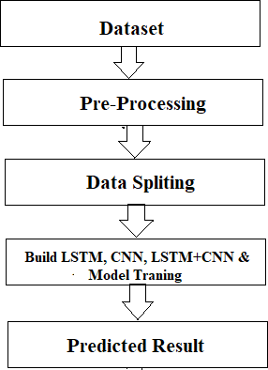

*Fig 3.1 Proposed Workflow*

The system presented here composes of five modules:-

* + 1. Input as Dataset
    2. Pre processing
    3. Data splitting
    4. Build & Model train Lstm, CNN and Hybrid approach of LSTM+CNN
    5. Output as Predicted Result

Attribute such as: price of open, high, low, close, adjusted close price taken from huge dataset are fed as input to the models for training to pre-process the data techniques like normalization & one hot encoding in applied on dataset. After this data is divided in two sets namely training & testing which are ratio of 80:20 respectively. Then, this set are used to train a model using 3 different approaches: LSTM, CNN and Hybrid approach of LSTM+CNNS. Finally, all these modules are evaluated using Root mean square error.

### Hybrid Approach of LSTM + CNN

In the hybrid approach, the Convolutional Neural Networks (CNNs) offer benefits in choosing sensible options and Long Short-Term Memory (LSTM) networks have proven sensible skills to find out to learn sequential data. Each approaches are reported to produce improved result. CNNs to possess to convolute filters over every input layer so as to get the simple options and CNNs have shown enhancements in computer vision, natural language processing and different tasks [14]. CNN may be a powerful tool to pick out features in order to improve the prediction accuracy [15]. The capabilities of LSTMs in learning data series by considering the previous outputs [16]

The multiple convolutional filters slide over the matrix to produce a new feature map and also the filters have numerous completely different sizes to generate different features. The Max- pooling layer is to calculate the most value as a corresponding feature to a particular filter. The output vectors of the Max-pooling layer become inputs to the LSTM networks to measure the long-run dependencies of feature sequences. One in all the benefits of the LSTMs is that the ability to capture the sequential data by considering the previous data. This layer takes the output vectors from the dropout layer as inputs. This layer include a set number of units or cells and also the input of every cell is that the output from the dropout layer. The final output of this layer has the same number of units within the network the outputs from LSTMs are merged and combined in one matrix then passed to a fully connected layer. The array is converted into a single output in the range between 0 and 1 using the fully connected layer, in order to be finally classified using sigmoid function [17].

**Chapter 4. Dataset, Implementation and Result**

### 3.2.1 Working of LSTM model

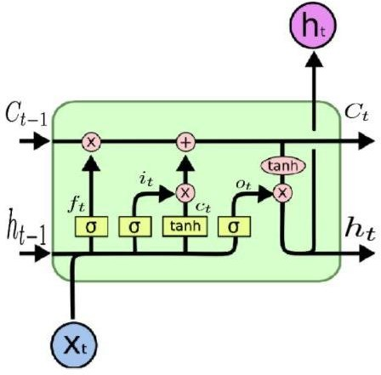

*Fig 3.2: LSTM Architecture* [12]

Long Short Term Memory is a kind of recurrent neural network. In RNN output from the last step is fed as input within the present step. It tackled the matter of long-term dependencies of RNN within which the RNN will not predict the word hold on within the long term memory however can offer additional accurate forecasts from the recent info. Because the gap length will increases RNN does not offer an economical performance. LSTM will by default retain the knowledge for a long period of time. It is used for processing, predicting and classifying on the basis of time-series data.

#### Structure of LSTM:

* + LSTM has a chain organization that contains four neural networks and different memory blocks called cells**.**
  + LSTM has a new structure called a memory cell. The memory cell makes the decisions about what information to store, and when to allow reading, writing and forgetting.
  + A memory cell contains three main gates:
    - Input gate- a new value flows into the memory cell.
    - Forget gate- a value remains in the memory cell.
    - Output gate- value in the memory cell is used to compute the output.

#### Applications of LSTM includes:

* + Language Modelling
  + Machine Translation
  + Image Captioning
  + Handwriting generation
  + Question Answering Chatbot

### Working of CNN model

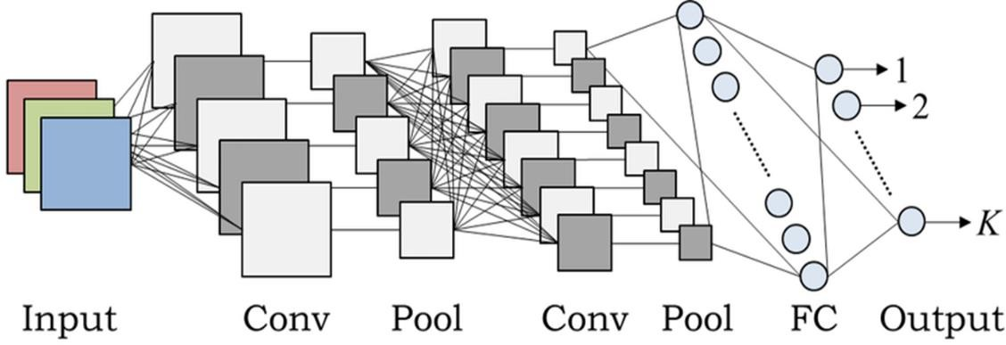

*Fig 3.3: CNN Architecture* [13]

#### Layer of CNN model:

* Convolution
* MAX Pooling
* Dropout
* Flatten
* Dense
* Activation
* **Convolution:** In the Convolution extract the featured from the input image. It given the output in matrix form.
* **MAX Pooling:** In the MAX polling it takes the largest element from a rectified feature map.
* **Dropout:** Dropout is randomly selected neurons are ignored during training.
* **Flatten:** Flatten feed output into a fully connected layer. It gives data in list form.
* **Dense:** A Linear operation in which every input is connected to every output by weight. It followed by a nonlinear activation function.
* **Activation:** It used sigmoid function and predict the probability 0 and 1.

#### Applications of CNN includes:

* + Decoding Facial Recognition
  + Analyzing Documents

### Dataset Detail

The dataset consists of the stock historical data from the National stock exchange (NSE) and captures the daily information of each stock from the National Stock Exchange. It collects different sectors of stock data, including Banking, Pharma, Petroleum, Software and Textiles and it including the opening price, the highest price, the lowest price, the closing price, the adjusted closing price and the volume of stock [18].

|  |  |
| --- | --- |
| **Sector** | **Stock Name** |
| Banking | ICICI Bank |
| Pharma | Sun Pharma |
| Petroleum | GSFC |
| Software | RS Software |
| Textiles | Vardmn Ploy |

*Table 4.1 Dataset Details*

### Tool & Technologies

### PYTHON

The language of select for this project was Python. This was a straightforward call for many reasons.

1. Python [19] as a language has a vast community behind it. Any problems which may be faced is simply resolved with visit to Stack Overflow. Python is the foremost standard language on the positioning that makes it is very straight answer to any question.
2. Python [19] is an abundance of powerful tools ready for scientific computing Packages. The packages like NumPy, Pandas and SciPy area unit freely available and well documented. These Packages will intensely scale back, and variation the code necessary to write a given program. This makes repetition fast.
3. Python is a language as [19] forgiving and permits for the program that appear as if pseudo code. This can be helpful once pseudo code give in tutorial papers should be required and verified. Using python this step is sometimes fairly trivial.

However, Python is [19] not without its errors. The python is dynamically written language and packages are area unit infamous for Duck writing. This may be frustrating once a package technique returns one thing that, for instance, looks like an array instead of being an actual array. Plus the standard Python documentation did not clearly state the return type of a method, this can’t lead without a lot of trials and error testing otherwise happen in a powerfully written language. This is a problem that produces learning to use a replacement Python package or library more difficult than it otherwise may be.

### NUMPY

Numpy is python package which provide scientific and higher level mathematical abstractions wrapped in python. It is [20] the core library for scientific computing, that contains a provide tools for integrating C, strong n-dimensional array object, C++ etc. It is also useful in random number capability, linear algebra etc.

Numpy’s array type augments the Python language with an efficient data structure used for numerical work, e.g., manipulating matrices. Numpy additionally provides basic numerical routines, like tools for locating Eigenvectors

### SCIKIT LEARN

Scikit-learn [21] could be a free machine learning library for Python. It features numerous classification, clustering and regression algorithms like random forests, k-neighbours, support vector machine, and it furthermore supports Python scientific and numerical libraries like SciPy and NumPy.

In Python Scikit-learn is specifically written, with the core algorithms written in Cython to get the performance. Support vector machines are enforced by a Cython wrapper around LIBSVM .i.e., linear support vector machines and logistic regression by a similar wrapper around LIBLINEAR.

### TENSORFLOW

In the TensorFlow [22]has an open source software library for numerical computation using data flow graphs. Inside the graph nodes represent mathematical formulae, the edges of graph represent the multidimensional knowledge arrays (tensors) communicated between them. The versatile architecture permits to deploy the computation to at least one or many GPUs or CPUs in a desktop, mobile device, servers with a single API. TensorFlow was firstly developing by engineers and researchers acting on the Google Brain Team at intervals Google's Machine Intelligence analysis organization for the needs of conducting deep neural networks research and machine learning, but, the system is generally enough to be appropriate in a wide range of alternate domains as well.

Google Brain's second-generation system is TensorFlow. Whereas the reference implementation runs on single devices, TensorFlow can run on multiple GPUs and CPUs. TensorFlow is offered on Windows, macOS, 64-bit Linux and mobile computing platforms together with iOS and Android.

### KERAS

Keras is [23] a high-level neural networks API, it is written in Python and also capable of running on top of the Theano, CNTK, or. TensorFlow. It was developed with attention on enabling quick experimentation. having the ability to travel from plan to result with the smallest amount doable delay is key to doing great research.Keras permits for straightforward and quick prototyping (through user-friendliness, modularity, and extensibility). Supports each recurrent networks and convolutional networks, also as combinations of the 2. Runs seamlessly on GPU and CPU. The library contains numerous implementations of generally used neural network building blocks like optimizers, activation functions, layers, objectives and a number of tools to create operating with text and image data easier. The code is hosted on GitHub, and community support forums embody the GitHub issues page, a Gitter channel and a Slack channel.

### COMPILER OPTION

Anaconda is [19] free premium open-source distribution of the R and Python programming languages for scientific computing, predictive analytics, and large-scale process that aim is to modify package managing and deployment. Package versions unit managed by the package management system conda.

### 4.2.7. JUPITER NOTEBOOK

The Jupyter Notebook is an open-source web application that enables to making and sharing documents that contain visualizations, narrative text, live code and equations. Uses include: data , data visualization, data transformation, statistical modelling, machine learning, numerical simulation, data cleaning and much more [24].

* 1. **Results**

**Step 1:** Dataset Analysis

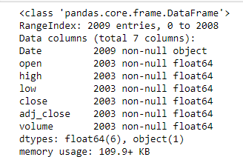

*Fig 4.1: Stock Dataset Information*

Firstly, I have performed Data analysis for stock price of companies. Fig. represent the date, open, close, high, low, adjusted close and volume of stocks details.

**Step 2:** Read Dataset

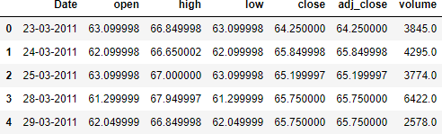

*Fig 4.2: Read Dataset*

After performing data analysis, I have read the dataset. It shows the dataset information table starting from the tail. There are 4274 data are available in each companies dataset.

**Step 3:** Graph of Close Price history

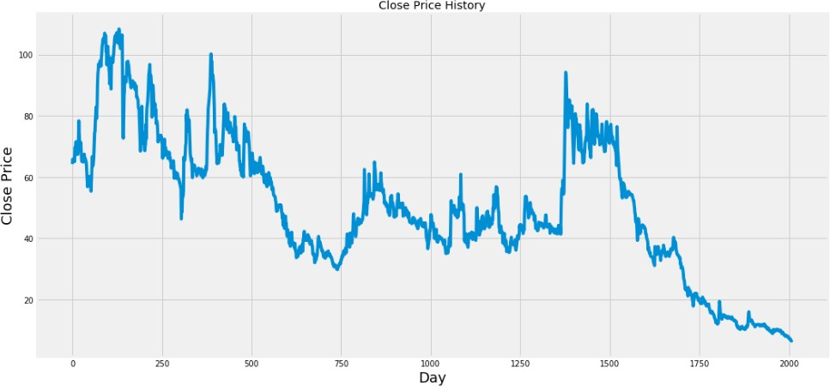

*Fig 4.3: Graph of Close Price history*

**Step 4:** Preprocessing

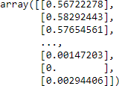

*Fig 4.4: Data Scaling*

After Dataset reading, I have performed preprocessing operation on the dataset. Here I apply Min-Max Scaler to preprocess the dataset. In preprocessing operation removes the noise into the data and convert data into 0 to 1 form.

**Step 5:** Train test Split

After performing preprocessing, I have divided the dataset into training and testing set. 80% of the data is used for the training while the remaining 20% of the data is used for testing..

**Step 6:** Model fitting of Long Short Term Memory architecture[25] [26], Convolution Neural Network architecture[27] & Hybride Approach of LSTM+CNN.

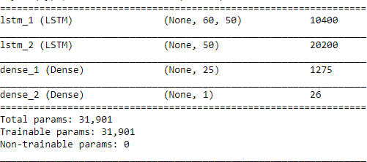

*Fig 4.5: LSTM Summary*

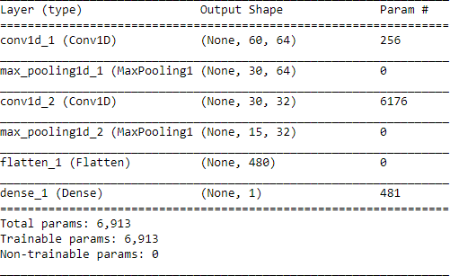

*Fig 4.6: CNN Summary*

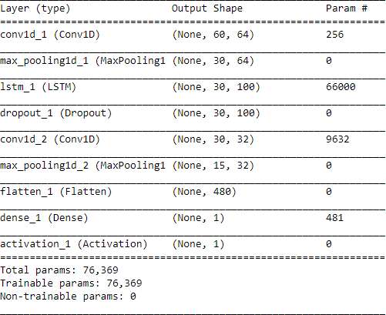

*Fig 4.7: Hybride Approach of LSTM + CNN Summary*

After generating training dataset, to apply training I have created LSTM, CNN & Hybride Approach of LSTM + CNN network using KERAS. several variations of this architecture using various numbers of layers and various size of Bottleneck layer.

**Step 7:** Apply Training

C:\Users\Janmesh Patel\Pictures\Screenshots\Screenshot (124).png

*Fig 4.8: Training Process*

To apply training, from the samples of Training data, 1543 samples are used for training and 460 samples are used for validation. Data is processed in a batch size of 1 and epoch is 1 for the entire training dataset.

**Step 8:** Predicted Result

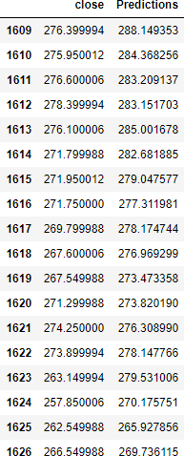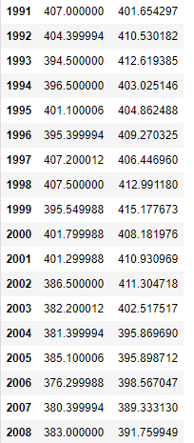

*Fig 4.9: Predicted Close Price*

|  |  |  |  |  |
| --- | --- | --- | --- | --- |
| Sector | Stock Name | RMSE | | |
| LSTM | CNN | LSTM+CNN |
| Banking | ICICI Bank | 22.5409 | 8.1499 | 9.1497 |
| Pharma | Sun Pharma | 19.4190 | 16.2015 | 16.0716 |
| Petroleum | GSFC | 5.4396 | 6.6478 | 4.6335 |
| Software | RS Software | 4.7152 | 3.7276 | 3.0633 |
| Textiles | Vardmn Ploy | 1.3909 | 2.5984 | 2.2982 |

*Table 4.2 Accuracy*

**Step 9:** Predicted Graph

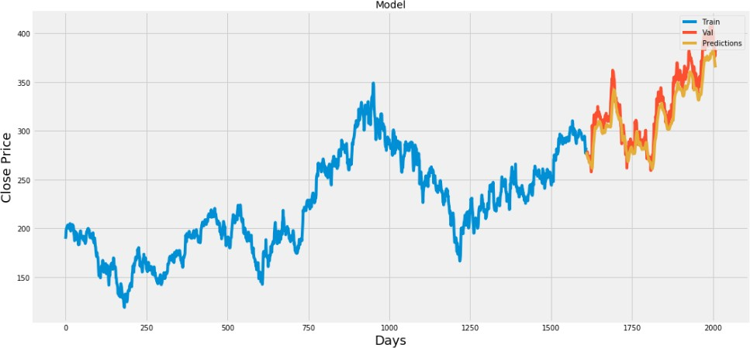

*Fig 4.10: Plot for Real vs Predicted value for ICICI Bank using LSTM*

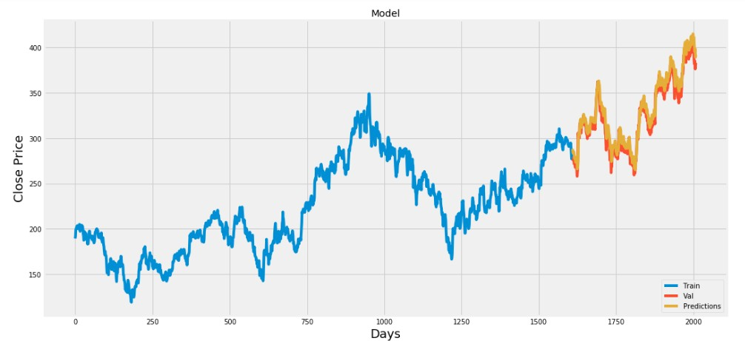

*Fig 4.11: Plot for Real vs Predicted value for ICICI Bank using CNN*

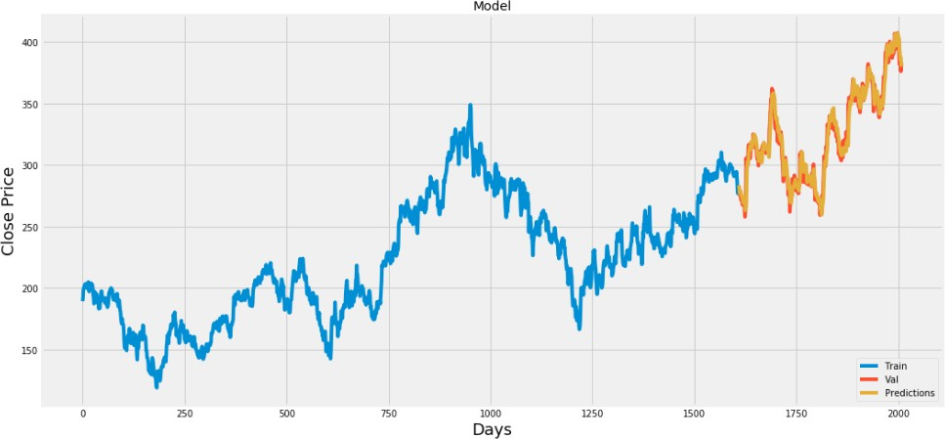*f*

*Fig 4.12: Plot for Real vs Predicted value for ICICI Bank using LSTM + CNN*

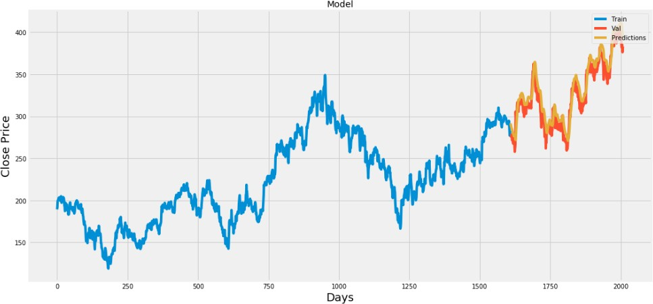

*Fig 4.13: Plot for Real vs Predicted value for SUNPHARMA using LSTM*

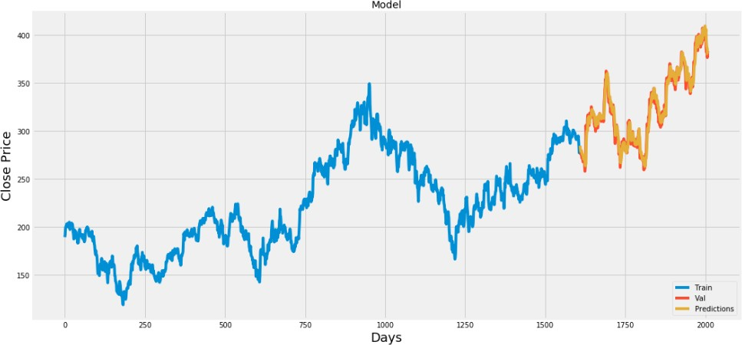

*Fig 4.14: Plot for Real vs Predicted value for SUNPHARMA using CNN*

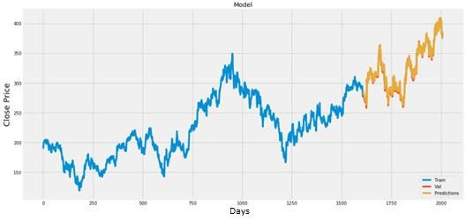

*Fig 4.15: Plot for Real vs Predicted value for SUNPHARMA using LSTM + CNN*

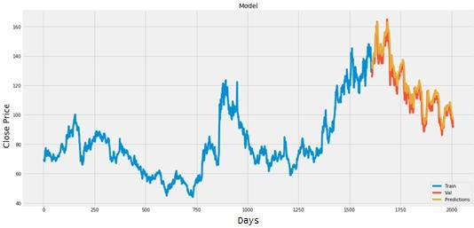

*Fig 4.16: Plot for Real vs Predicted value for GSFC using LSTM*

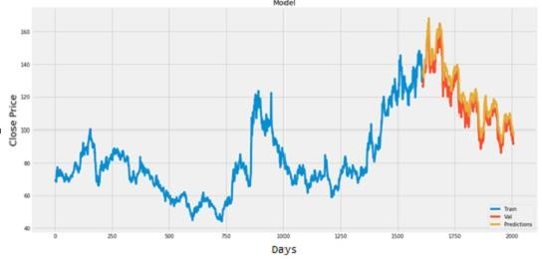

*Fig 4.17: Plot for Real vs Predicted value for GSFC using CNN*

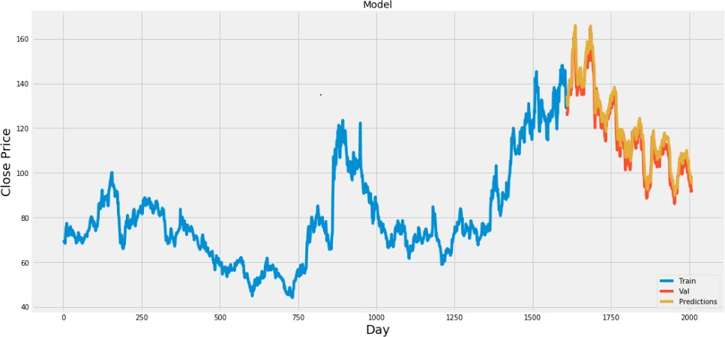

*Fig 4.18: Plot for Real vs Predicted value for GSFC using LSTM + CNN*

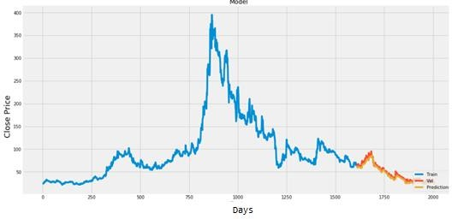

*Fig 4.19: Plot for Real vs Predicted value for RSSOFTWARE using LSTM*

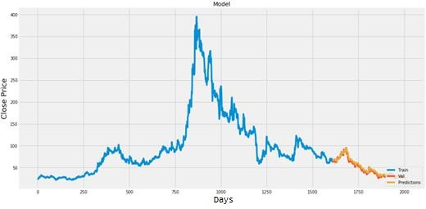

*Fig 4.20: Plot for Real vs Predicted value for RSSOFTWARE using CNN*

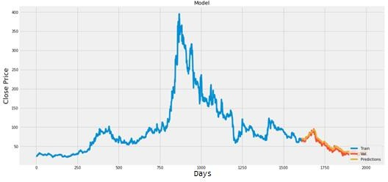

*Fig 4.21: Plot for Real vs Predicted value for RSSOFTWARE using LSTM + CNN*

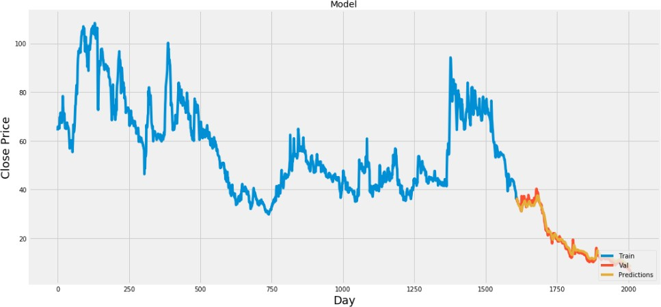

*Fig 4.22: Plot for Real vs Predicted value for VARDMANPOLY using LSTM*

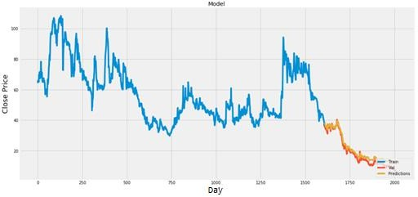

*Fig 4.23: Plot for Real vs Predicted value for VARDMANPOLY using CNN*

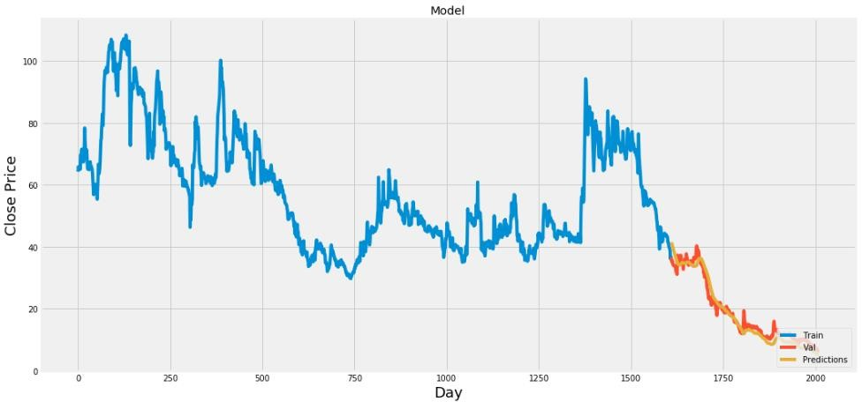

*Fig 4.24: Plot for Real vs Predicted value for VARDMANPOLY using LSTM + CNN=*

**Chapter 5. Conclusion and Future Work**

In report, we will compare a machine learning models like LSTM model, the CNN model and also the hybrid approach of LSTM + CNN model. We have a tendency to train the model using the data of NSE listed companies to predict the stock future value. This is shows the proposed method is capable to distinctive around interrelation with the data. Also, it is evident from the results that, Hybrid approach of LSTM+CNN model is capable to identify the changes in trends. For the projected method the Hybrid approach of LSTM+CNN is known as the best model. It uses the information given at a specific instant for prediction. Even if the other two models LSTM and CNN are utilized in a lot of other time-dependent data analysis, it is not outperforming over the Hybrid approach of LSTM+CNN architecture in this case. This is often because of quick changes occur in stock market. The changes in the stock market is not always be in a regular pattern or not always follow the continuous cycle. Based on the companies and sectors, the existence of the trends and the period of their existence will differ. The analysis of this type of cycles and trends can offer a more profit to the investors. In future work, we add more stock market data and compare more model to improve accuracy of predicted stock price.

In the future, for better accuracy model can be trained with more varied and detailed data. Also, other algorithms along with proposed can be used to create a new hybrid model.

# Bibliography and References

1. “Stock price prediction using LSTM, RNN and CNN-sliding window model - IEEE Conference Publication.” https://ieeexplore.ieee.org/document/8126078 (accessed Dec. 27, 2019).
2. J. Jagwani, M. Gupta, H. Sachdeva, and A. Singhal, “Stock Price Forecasting Using Data from Yahoo Finance and Analysing Seasonal and Nonseasonal Trend,” in *2018 Second International Conference on Intelligent Computing and Control Systems (ICICCS)*, Madurai, India, Jun. 2018, pp. 462–467, doi: 10.1109/ICCONS.2018.8663035.

[3] I. Parmar *et al.*, “Stock Dec. 2018, pp. 574–576, doi: 10.1109/ICSCCC.2018.8703332.

1. Y. Lei, K. Zhou, and Y. Liu, “Multi-Category Events Driven Stock Price Trends Prediction,” in *2018 5th IEEE International Conference on Cloud Computing and Intelligence Systems (CCIS)*, Nanjing, China, Nov. 2018, pp. 497–501, doi: 10.1109/CCIS.2018.8691392.
2. B. Jeevan, E. Naresh, B. P. V. kumar, and P. Kambli, “Share Price Prediction using Machine Learning Technique,” in *2018 3rd International Conference on Circuits, Control, Communication and Computing (I4C)*, Bangalore, India, Oct. 2018, pp. 1–4, doi: 10.1109/CIMCA.2018.8739647.
3. M. Usmani, S. H. Adil, K. Raza, and S. S. A. Ali, “Stock market prediction using machine learning techniques,” in *2016 3rd International Conference on computer and Information Sciences (ICCOINS)*, 2016, pp. 322–327.
4. J. Du, Q. Liu, K. Chen, and J. Wang, “Forecasting stock prices in two ways based on LSTM neural network,” in *2019 IEEE 3rd Information Technology, Networking, Electronic and Automation Control Conference (ITNEC)*, Mar. 2019, pp. 1083–1086, doi: 10.1109/ITNEC.2019.8729026.
5. S. E. Gao, B. S. Lin, and C.-M. Wang, “Share Price Trend Prediction Using CRNN with LSTM Structure,” in *2018 International Symposium on Computer, Consumer and Control (IS3C)*, Dec. 2018, pp. 10–13, doi: 10.1109/IS3C.2018.00012.
6. T. Gao, Y. Chai, and Y. Liu, “Applying long short term momory neural networks for predicting stock closing price,” in *2017 8th IEEE International Conference on Software Engineering and Service Science (ICSESS)*, Beijing, China, Nov. 2017, pp. 575–578, doi: 10.1109/ICSESS.2017.8342981.
7. R. Y. Nivetha and C. Dhaya, “Developing a Prediction Model for Stock Analysis,” in *2017 International Conference on Technical Advancements in Computers and Communications (ICTACC)*, Melmaurvathur, India, Apr. 2017, pp. 1–3, doi: 10.1109/ICTACC.2017.11.
8. Z. Yeze and W. Yiying, “Stock Price Prediction Based on Information Entropy and Artificial Neural Network,” in *2019 5th International Conference on Information Management (ICIM)*, Cambridge, United Kingdom, Mar. 2019, pp. 248–251, doi: 10.1109/INFOMAN.2019.8714662.
9. “Basic LSTM Unit Transfer Function Diagram from [10] | Download Scientific Diagram.” https[://www](http://www.researchgate.net/figure/Basic-LSTM-Unit-Transfer-Function-).[researchgate.net/figure/Basic-LSTM-Unit-Transfer-Function-](http://www.researchgate.net/figure/Basic-LSTM-Unit-Transfer-Function-) Diagram-from-10_fig8_308804546 (accessed Jun. 03, 2020).
10. “Fig. 1: An example of CNN architecture.,” *ResearchGate*. https:/[/www](http://www.researchgate.net/figure/An-example-of-CNN-architecture_fig1_320748406).[researchgate.net/figure/An-example-of-CNN-architecture_fig1_320748406](http://www.researchgate.net/figure/An-example-of-CNN-architecture_fig1_320748406) (accessed Jun. 03, 2020).
11. Y. Kim, “Convolutional Neural Networks for Sentence Classification,” in *Proceedings of the 2014 Conference on Empirical Methods in Natural Language Processing (EMNLP)*, Doha, Qatar, Oct. 2014, pp. 1746–1751, doi: 10.3115/v1/D14-1181.
12. B. Athiwaratkun and K. Kang, “Feature Representation in Convolutional Neural Networks,” *ArXiv150702313 Cs*, Jul. 2015, Accessed: Apr. 14, 2020. [Online]. Available: [http://arxiv.org/abs/1507.02313.](http://arxiv.org/abs/1507.02313)
13. F. A. Gers, D. Eck, and J. Schmidhuber, “Applying LSTM to Time Series Predictable through Time-Window Approaches,” in *Artificial Neural Networks — ICANN 2001*, Berlin, Heidelberg, 2001, pp. 669–676, doi: 10.1007/3-540-44668-0_93.
14. J. Han and C. Moraga, “The Influence of the Sigmoid Function Parameters on the Speed of Backpropagation Learning,” in *Proceedings of the International Workshop on Artificial Neural Networks: From Natural to Artificial Neural Computation*, Berlin, Heidelberg, Jun. 1995, pp. 195–201, Accessed: Apr. 13, 2020. [Online].
15. “NSE Listed 1000+ Companies’ Historical Data.” https://kaggle.com/abhishekyana/nse- listed-1384-companies-data (accessed Jul. 07, 2020).
16. A. Tipirisetty, “Stock Price Prediction using Deep Learning,” p. 60.
17. “Python Numpy Tutorial | Learn Numpy Arrays With Examples,” *Edureka*, Jul. 14, 2017. https:/[/www](http://www.edureka.co/blog/python-numpy-tutorial/).[edureka.co/blog/python-numpy-tutorial/](http://www.edureka.co/blog/python-numpy-tutorial/) (accessed Apr. 21, 2020).
18. “Scikit-learn Tutorial: Machine Learning in Python – Dataquest.” https:/[/www](http://www.dataquest.io/blog/sci-kit-learn-tutorial/).[dataquest.io/blog/sci-kit-learn-tutorial/](http://www.dataquest.io/blog/sci-kit-learn-tutorial/) (accessed Apr. 21, 2020).
19. J. Brownlee, “Introduction to the Python Deep Learning Library TensorFlow,” *Machine Learning Mastery*, May 04, 2016. https://machinelearningmastery.com/introduction- python-deep-learning-library-tensorflow/ (accessed Apr. 21, 2020).
20. “Home - Keras Documentation.” https://keras.io/ (accessed Apr. 21, 2020).
21. “Project Jupyter.” https[://www](http://www.jupyter.org/).[jupyter.org](http://www.jupyter.org/) (accessed Apr. 19, 2020).
22. K. Team, “Keras documentation: Search Keras documentation.” https://keras.io/search.html?query=lstm (accessed Jul. 07, 2020).
23. K. Joshi, *kartik-joshi/Stock-predection*. 2020.
24. K. Team, “Keras documentation: The Sequential model.” https://keras.io/guides/sequential_model/ (accessed Jul. 07, 2020).

Market Prediction Using Machine Learning,” in *2018 First International Conference on Secure Cyber Computing and Communication (ICSCCC)*,

# APPENDIX A: ABBRAVIATION

|  |  |  |
| --- | --- | --- |
| **Sr. No.** | **Abbreviation** | **Meaning** |
| 1 | CNN | Convolutional Neural Network |
| 2 | LSTM | Long Short Term Memory |
| 3 | RNN | Recurrent Neural Network |
| 4 | MLP | Multi-Layer Perceptron |
| 5 | CRNN | Convolutional Recurrent Neural Network |
| 6 | ANN | Artificial Neural Network |
| 7 | KSE | Karachi Stock Exchange |
| 8 | SVM | Support Vector Machine |
| 9 | MSE | Mean Square Error |
| 10 | RMSE | Root Mean Square Error |
| 11 | MA | Moving Average |
| 12 | EMA | Exponential Moving Average |
| 13 | NSE | National Stock Exchange |
| 14 | BSE | Bombay Stock Exchange |
| 15 | P/E ratio | Profit per Earning ratio |
| 16 | ARIMA | Auto Regressive Integrated Moving Average |
| 17 | FEX | Foreign Exchange |
| 18 | SLP | Single Layer Perceptron |
| 19 | RBF | Radial Basis Function |
| 20 | MLR | Multiple Linear Regression |
| 21 | MAE | Mean Absolute Error |
| 22 | GPU | Graphics Processing Units |
| 23 | CPU | Control Processing Units |
| 24 | CSV | Comma Separated Values |
| 25 | GSFC | Gujarat State Fertilizers & Chemicals Limited |
| 26 | NASDAQ | National Association of Securities Dealers Automated  Quotations |